Week 3 reading

Ch. 5 objects

* Function = method
* Object literal – object that is created directly in language wrapping all properties and methods in curly braces
* Usually will be const
* Accessing properties – superman.name, superman[‘name’]
* hasOwnProperty() method – checks object for properties

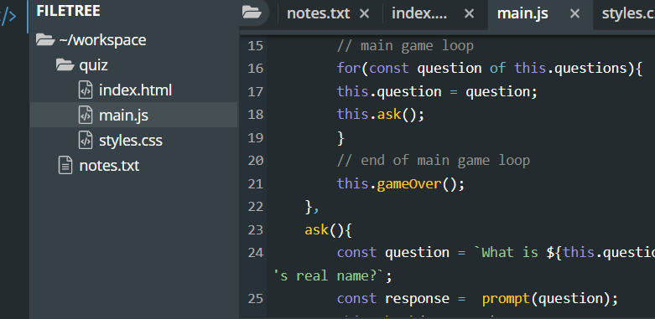

Ch. 6 Document object model

* allows access to elements of web page
* .nodeType helps you find out what type of node it is
* Query selectors allows you to use css notation to find first element in document that matches selector
* InnerHTML returns all child elements of element string
* Live collections – getElementsByClassName(), update to reflect any changes on page

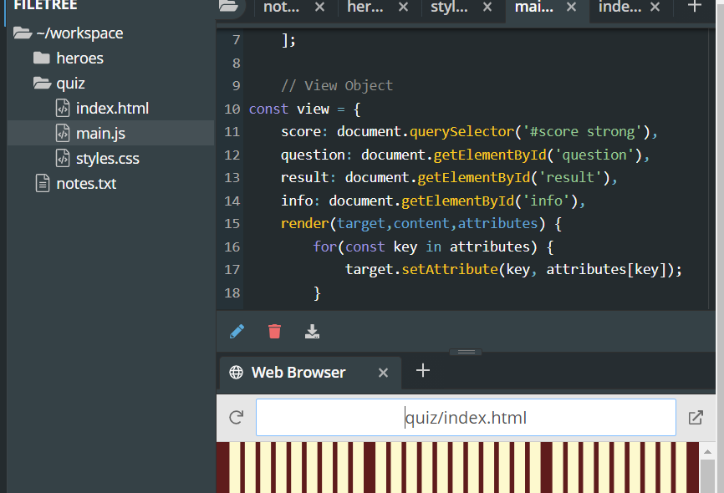

Ch 7

* Event listener – sends an alert when something happens
* .addEvenListener(“click”, doSomething);
* Can be called without node
* Inline – onClick
* Target property – returns reference to node
* Events can include – mouse, keyboard, modifier keys, touch
* .removeEventListener(‘click’, remove)
* 